**Multi-Factor Authentication Set-up Instructions**

**Step #1**

Download the Microsoft Authenticator App for your device:  
[Apple Devices click here](https://apps.apple.com/us/app/microsoft-authenticator/id983156458)  
[Android Devices click here](https://play.google.com/store/apps/details?id=com.azure.authenticator&hl=en_CA&gl=US)  
[Blackberry](https://www.firstpost.com/tech/news-analysis/blackberry-messenger-to-shut-down-on-31-may-heres-how-you-can-keep-using-it-6479021.html)… - Tony, don’t worry. We’ll take care of you in person 😊

**Continue to Step #2 on the following page…**

**Step #2**Once the app is installed, please go to [Office.com](https://login.microsoftonline.com/) on your computer (not your phone) and log-in.   
Don’t know your password? You’re fired! Just kidding, give us a call and we’ll reset it for you.   
Pick your victim below:

1. Avi Balsingh | 416-510-6806
2. Thom Faires | 416-510-6850
3. Martin Smith | 613-817-3514

**Step #3 – More info required**

**Click Next – You can do it!**

**Step #4 – How should we contact you?**

1. **Choose Mobile App (you previously downloaded this to your Newcom phone)**
2. **Click your only option “**Receive notifications for verification**”**
3. **Click setup …a cool QR code appears. Well, as cool as a QR Code can be.**

**Step #5 - Open the Microsoft Authenticator App on your phone**

1. **Under Authenticator (click bottom icon if you’re not already there) Click the + symbol (Top Right)**
2. **Choose “Work or School account” (Because everyday at Newcom is a learning opportunity!)**
3. **Pop-up – Choose “Scan QR code”**
4. **Point your camera at your screen**
5. **Back to your computer now – Click Next to close the QR Code**
6. **Click Next to complete contact method**

**Step #6 - In case you lose access to the mobile app**

1. **Choose Canada (+1)**
2. **Enter your Newcom Cell Phone Number**
3. **Next!**

**Step #7 - In case you lose access to the mobile app**

1. **Now you will be presented with an App Password. Hit the copy button and paste it in a safe place. …not an email.**
2. **Don’t know how to copy and paste? Sign up for Tom’s New Podcast – “Computers for Seniors”**Graphical user interface, application

   Description automatically generated

**Step 8 – Almost there!**

**Approve your sign in request on your phone in the Authenticator App.**

**Yay! You’re pretty much done (insert sigh of relief). Some of your office apps such as Outlook will request authentication on your phone app. If you’re using an old version of Office, you may have to enter the App Password you saved in Step #7. If you have any issue don’t hesitate to reach out:**

1. Avi Balsingh | 416-510-6806
2. Thom Faires | 416-510-6850
3. Martin Smith | 613-817-3514

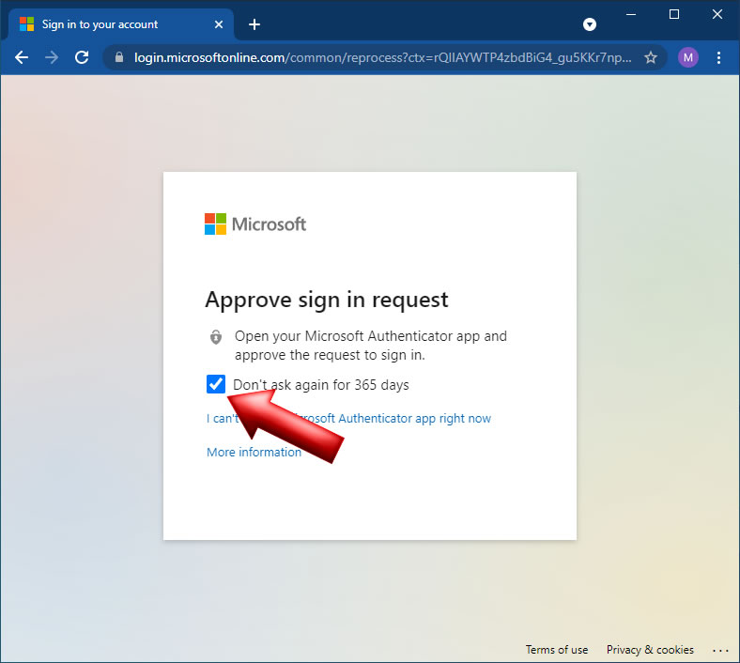

**Step 9 – Victory!**

**You’ve just stopped the hackers in their tracks. Pat yourself on the back.**

**You’re awesome! 😊**